

OUTREACH SCHOOLS EXAMINATIONS BOARD
BEGINNING OF TERM III EXAMINATION 2023
P.5 INTEGRATED SCIENCE
Time Allowed: 2hours 15 Minutes

Pupil’s Name: ……………………………………..……………………
Class: ……………………………..………………………………………
School Name: ………………………………………………………….
FOR EXAMINERS’

USE ONLY
Qn. No. | MARKS | EXR’S  No.
1 - 10
11 – 20
21 – 30
31 – 40
41 – 43
44 – 46
47 – 49
50 - 52
53 - 55
TOTAL

Read the following instructions carefully:
- This paper has two sections: A and B
- Section A has 40 questions (40 marks)
- Section B has 15 questions (50 marks)
- Answer all questions. All the working for both sections A and B must be shown in the spaces provided.
- All working must be done using a blue or black ball point pen or ink. Any work done in pencil will NOT be marked except drawings and diagram.
- Unnecessary changes in your work and handwriting that cannot be easily read may lead to loss of marks.
- Do not fill anything in the table indicated
“For examiners’ use only” and the boxes inside the question paper.
©2023 Outreach Schools Examination Board Turn Over
SECTION A.
- Name the domestic animal that guards our homes.
_________________________________________________________________
- Give one way of controlling soil erosion in hilly areas.
_________________________________________________________________
- Write one danger of growing crops near anthills.
_________________________________________________________________
- Why do we save resources at home?
_________________________________________________________________
- State one mineral salt needed for strong bone formation.
_________________________________________________________________
- What happens to salt when it is put in water?
_________________________________________________________________
- Give the function of the tool below on a crop farm.
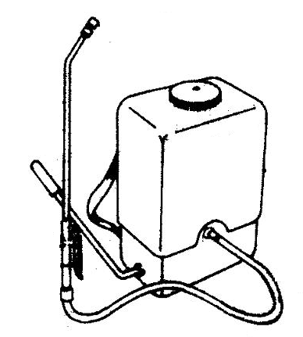

_______________________________________________
- How are hooks useful to a tape worm?
_________________________________________________________________
- Write the importance of hydrochloric acid in the stomach.
_________________________________________________________________
- State one danger of potholes on a road.
_________________________________________________________________
- Give one effect of polio to an individual.
_________________________________________________________________
- Why is burning of rubbish not a good practice to the environment.
_________________________________________________________________
- How do people benefit from having regular physical exercises?
_________________________________________________________________
- Which part of a worker bee enables it to carry pollen?
_________________________________________________________________
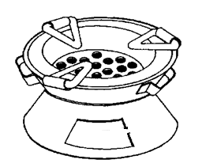
The diagram below is of a common stove. Use it to answer question 15 and 16.
P

- Identify the fuel used in the above stove.
_________________________________________________________________
- How is hole marked P useful to the stove above?
_________________________________________________________________
- Give one way of separating mixtures.
_________________________________________________________________
- Name the common liquid used to make ORS.
_________________________________________________________________
- Which part of an Irish potato is eaten by people?
_________________________________________________________________
- How does a chameleon protect itself?
_________________________________________________________________
- Give the use of a rope to a goat farmer.
_________________________________________________________________
- What should one consider when selecting seeds or other materials for planting?
_________________________________________________________________
- What is the role of chlorophyll during the process of photosynthesis?
_________________________________________________________________
- Identify the water source shown below.
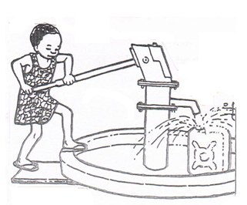

________________________________________________

- Give one sign of poor sanitation in a home.
_________________________________________________________________
- Why do health workers wipe thermometers using spirit after using them?
_________________________________________________________________
- Which method of preserving food involves the use of slow burning fire?
_________________________________________________________________
- Name the animal product we use to make drums.
_________________________________________________________________
- Why does cooking oil settle on top of water when put in the same container?
_________________________________________________________________
- What is a habitat?
_________________________________________________________________
- Write any one method of extracting honey.
_________________________________________________________________
The diagram below shows a bean seed.
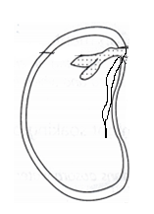
T

- Name part marked T on the diagram above.
_________________________________________________________________
- Give one importance of swamps in our environment.
_________________________________________________________________
- Why should fruits be washed before eating them?
_________________________________________________________________
- Draw this item we use to give first aid to casualties.
plaster
- Which type of teeth is responsible for cutting food?
_________________________________________________________________
- Identify one place at school that can be cleaned by scrubbing.
_________________________________________________________________
- Give one way of finding the volume of an object.
_________________________________________________________________
- Name one breed of rabbits kept in Uganda.
_________________________________________________________________
- How is water important to a germinating seed?
_________________________________________________________________
SECTION B:
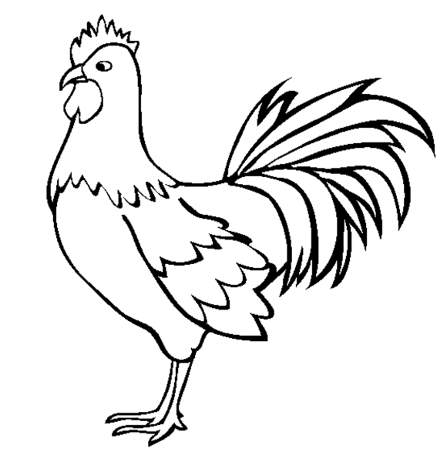
The diagram below shows a bird. Use it to answer question 41.
Z
Y
X
W

- (a) Name the parts marked W and Y.
- W _________________________________________________________
- Y _________________________________________________________
(b) How are the following parts useful to a bird?
(i) X __________________________________________________________
(ii) Z __________________________________________________________
- (a) Give one example of useful fungi in our environment.
____________________________________________________________
(b) How do most fungi reproduce?
____________________________________________________________
(c) Why can’t fungi make their own food?
____________________________________________________________
(d) Name one fungal disease that attacks people.
____________________________________________________________
- The information below was collected by teachers during a health parade.
Pupils | Bathing | Brushing teeth | Washing the face
Pupil U | x | √ | √
Pupil W | √ | √ | √
Pupil X | x | √ | x
Pupil Z | x | √ | √
Key:
x - activity not done √ - activity done
- Identify the activity which was done by all pupils.
____________________________________________________________
- Which activity did most pupils miss?
____________________________________________________________
- Who of the four pupils above had the best personal hygiene?
____________________________________________________________
- Give one other activity that can be included on the table above.
____________________________________________________________
- (a) Write one food stuff under the following.
- Animal proteins
____________________________________________________________
- Plant proteins
____________________________________________________________
(b) How are proteins important in our bodies?
____________________________________________________________
(c) Give one danger of poor feeding to people.
____________________________________________________________
- (a) Name one root tuber that is propagated using stem cutting.
____________________________________________________________
(b) Write any two pests that attack root crops in the garden.
(i) ____________________________________________________________
(ii) ____________________________________________________________
(c) Why do people in Uganda grow root crops?
____________________________________________________________
- (a) Which gas occupies the lowest percentage in the atmosphere?
____________________________________________________________
(b) Apart from the above gas, write two other gases in air.
(i) ____________________________________________________________
(ii) ____________________________________________________________
(c) Give one human activity that requires moving air.
____________________________________________________________
The diagram below shows changes in states of matter. Use it to answer question 47.
L
Evaporation
K
M
N
gas

- (a) Name the physical processes marked K and L.
(i) K __________________________________________________________
(ii) L __________________________________________________________
(b) Identify any one object that exists in the state of matter marked N.
____________________________________________________________
(c) Which form of energy is needed for processes L to take place?
____________________________________________________________
- (a) Give two effects of accidents to people.
- ____________________________________________________________
- ____________________________________________________________
(b) How can you prevent burns at home?
____________________________________________________________
(c) Give one way we can manage an accident at home.
____________________________________________________________
- Match the items in list A to those in list B correctly.
List A List B
- Vaccination improves breeds of birds.
- Debeaking controls poultry diseases.
- Providing perches provides exercises to birds.
- Cross breeding controls egg eating.
- Vaccination ___________________________________________
- Debeaking ___________________________________________
- Providing perches ___________________________________________
- Cross breeding ___________________________________________
- (a) Write Human Immunodeficiency Virus in short.
____________________________________________________________
(b) Which disease is caused by Human Immunodeficiency virus?
____________________________________________________________
(c) Give one way you would care for a person with the above disease.
____________________________________________________________
(d) How can a P.5 pupil avoid getting the above disease?
____________________________________________________________
- (a) Identify any two projects that can be done by P.5 pupils at school.
- ____________________________________________________________
- ____________________________________________________________
(b) Why should a school have projects like those you have mentioned above?
____________________________________________________________
(c) Write any one thing needed to start a project at school.
____________________________________________________________
The diagrams below show things people make at home. Use it to answer question 52.
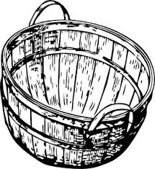  A | 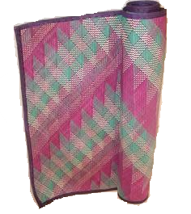B
- (a) Name item marked A above.
____________________________________________________________
(b) Write one material used to make item B.
__________________________________________________________
(c) State one place in the environment where material for making item B can
be got.
____________________________________________________________
(d) Why do people make item marked A at home?
____________________________________________________________
- (a) Name the part of the alimentary canal where;
- digestion ends ___________________________________________
- water is absorbed ___________________________________________
(b) Write one disorder of the digestive system.
____________________________________________________________
(c) Give one way of keeping the digestive system in good working condition.
____________________________________________________________
- (a) Write two elements of weather.
- ____________________________________________________________
- ____________________________________________________________
(b) State one way of managing rainy weather.
____________________________________________________________
(c) Why do most farmers harvest their seeds during the dry season?
____________________________________________________________
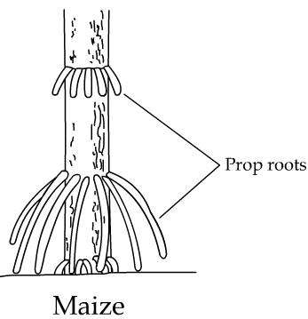
The diagram below shows part of a plant. Use it to answer question 55.
T

- (a) Name the roots marked T above.
____________________________________________________________
(b) How are the roots you have named above useful to the plant?
____________________________________________________________
(c) Write two plants that develop the above roots.
(i) ____________________________________________________________
(ii) ____________________________________________________________

*************** END ***************

